Mini Project -1

Application Deployment

Step1:

Cloned the Repo with the given detailed and added in Locally

Screenshot mentioned Below:

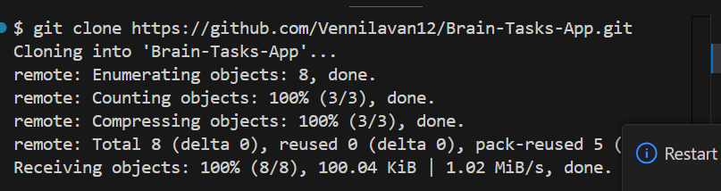

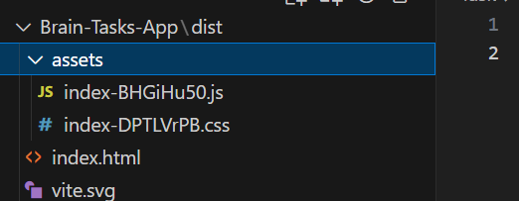

In the Server Also we gonna try ,cloned the github repo in the server also

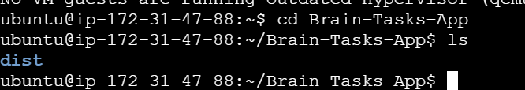

Step 2:

Dockerize the image using build command

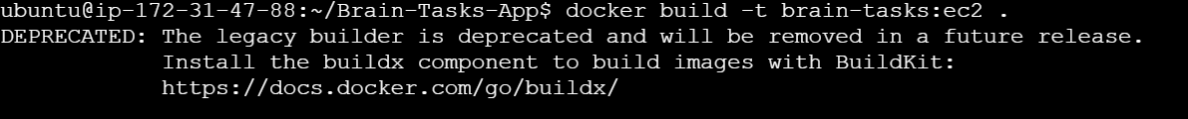



And Run through the 3000 port and we need to verify with my public Ip its running

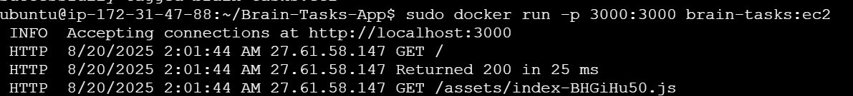

Hit with my Public IP <http://3.110.157.212:3000/> its working

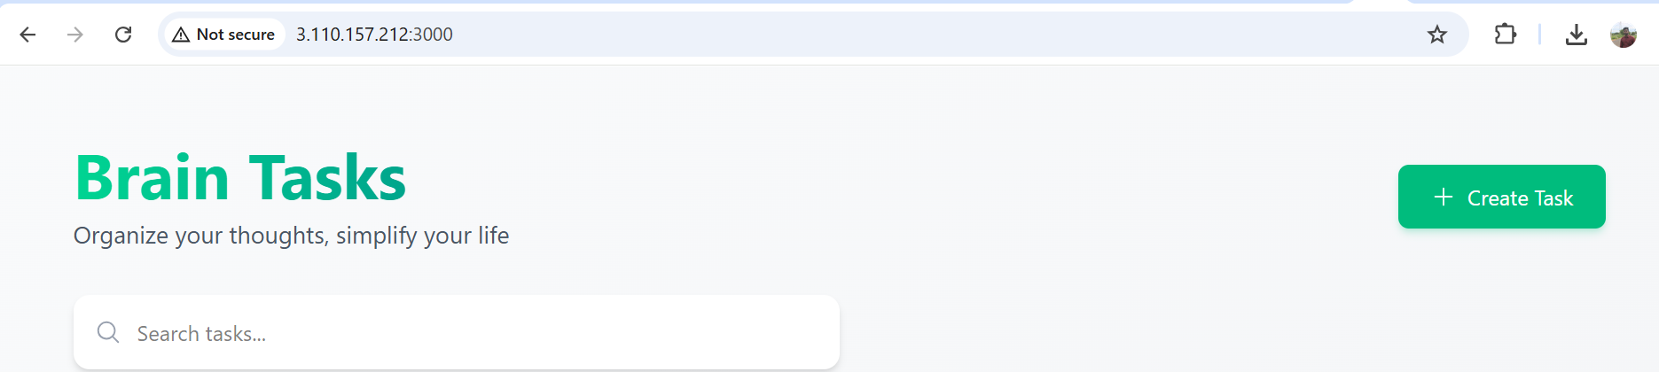

Step3:

By creating the Docker image we are going to push into the ECR so for that we installed awscli and logged into that

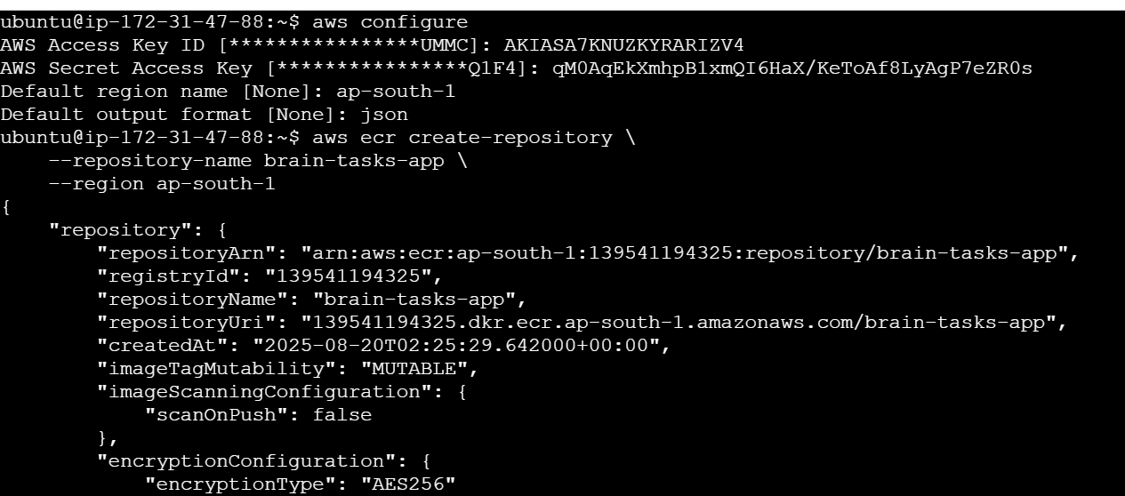

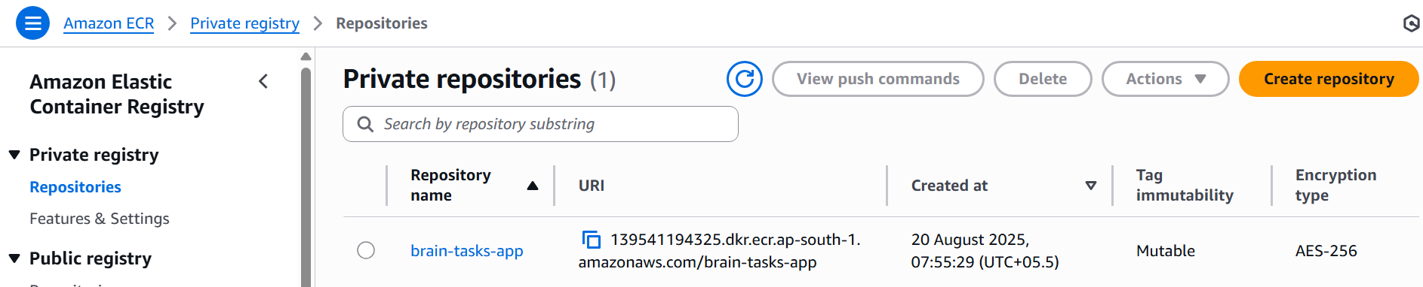

And using push command we pushing the image into ECR

# 1. Build your Docker image

sudo docker build -t brain-tasks-app .

# 2. Tag the image with your ECR repo URL

sudo docker tag brain-tasks-app:latest 139541194325.dkr.ecr.ap-south-1.amazonaws.com/brain-tasks-app:latest

# 3. Authenticate Docker with ECR

aws ecr get-login-password --region ap-south-1 \

| sudo docker login --username AWS --password-stdin 139541194325.dkr.ecr.ap-south-1.amazonaws.com

# 4. Push the image to ECR

sudo docker push 139541194325.dkr.ecr.ap-south-1.amazonaws.com/brain-tasks-app:latest



